FOSTER CITY POLICE DEPARTMENT

2017 | ANNUAL CRIME REPORT

Joseph Pierucci- Chief of Police

Report prepared by
Sgt. Dave Orlando

Table of Contents

Page 3-4 Executive Summary

Page 5 Department Philosophy and Value Statement Page 6 Strategic Plans and Crime Prevention
Page 7-9 Case Highlights

Page 10 Patrol Activity

Page 11-17 Annual Crime Statistics/Maps

Executive Summary

This is the 2017 Foster City Police Department Annual Crime Report. The statistics gathered herein were obtained via internal records management tabulation and give a clear and concise description of the criminal activity that occurred within our City during the calendar year 2017. This report also details the efforts and accomplishments of our Department members toward curtailing these activities via crime prevention measures and/or the arrest of suspects involved in various criminal incidents, and our continual goal of providing “Excellent service, every call, every contact, every day, and then some!”

FCPD personnel participated in the numerous countywide meetings and operations with the following groups:
- Countywide Investigators Meetings
- Narcotic Task Force
- Gang Task Force
- Vehicle Theft Task Force
- Human Trafficking Task Force
- Burglary Enforcement Suppression Team

During these meetings and operations, participants discussed crime trends and criminal activity throughout San Mateo County and the Bay Area. According to the participating agencies, there again was a steady increase in property crimes. Foster City was able to hold that rise to a minimum. This was primarily due to our community partnerships and the diligent efforts of FCPD personnel to deter crime in our City. We saw significant decreases in several crime categories, including a 27% drop in commercial burglaries, a 30% drop in general thefts (although still up 30% from 2015), a 45% decrease in vandalism, and a 5% decrease in stolen vehicles. The City saw an increase in three crime categories: residential burglaries increased by 33%, thefts from vehicles increased by 65% (and have doubled since 2015), and graffiti had a slight rise of 3%. Total property crimes increased by 10% and were up 35% since 2015. Many of these thefts were classified as felonies prior to the passage of Proposition 47. During numerous interviews of suspects arrested for these crimes, they acknowledged the lack of consequences when they are caught, as they will likely be released with a citation.

As we move into 2018, we continue to feel the impacts of the changes in state law such as the passing of Proposition 57, the previous passing of Proposition 47, and Post Release Community Supervision (PRCS). The full impact of these changes is still unknown, but statistical comparisons continue to show increases in property crimes since the passage of the propositions. That said, Foster City community members can rest assured that proactive crime fighting and prevention efforts, tried, true, and innovative, will continue as part of our commitment to maintaining Foster City as a great place to live, work, and play.

Philosophy

We, the members of the Foster City Police Department, are dedicated to providing superior service in a positive and caring manner, incorporating citizen input and external resources to help ensure the protection of life and property and the highest quality of life within the community we serve. We are problem solvers, who look at all the aspects of quality of life for the residents and apply our knowledge and expertise to improve and maintain that quality.

We Provide “Excellent service, every call, every contact, every day, and then some!”

Safest City Recognition

In 2017, Foster City was again included in a list of one of the 100 safest cities in the United States, ranking #63, according to Neighborhood Scout, a national residential and commercial data tracking company. Moreover, Foster City was identified as the 6th safest city of municipalities with a population of more than 10,000 residents in California.

Strategic Plan Achievements

With the 2017 Strategic Plan as our guide, the Foster City Police Department conducted several activities which helped further our overall mission of providing excellent service on every call, during every contact, every day. As a result, we celebrate another successful year in which our citizens can safely live and work in Foster City.

FCPD officers spent much of their free patrol time conducting officer initiated activities such as, but not limited to, car stops, pedestrian stops, walk-throughs, bicycle stops, passing checks, home safety surveys, and auto security report cards. These efforts resulted in on-view arrests, the identification of individuals with a criminal history/intent and the prevention of criminal activity by being highly visible and interactive with our community.

Crime Prevention

In 2017, Foster City Police Department Officers conducted over 50 Community Outreach Activities (COP) at various residences, businesses, schools, and organizations. We assisted a neighborhood watch group which hosted a “National Night Out” community event. We completed two residential security surveys and two in-depth CPTED (Crime Prevention Through Environmental Design) surveys for local businesses. Crime Prevent-Community Outreach worked with new developers in Foster City to provide design ideas to enhance crime prevention at their properties. The FCPD, the Foster City Fire Department, and Public Works all hosted our joint Annual Open Houses, allowing members of our community to interact with our staffs and get to know them. We provided residents with an opportunity to tour our stations and ask questions about our equipment/procedures. During the holiday season, Crime Prevention-Community Outreach and Youth Services brought awareness to the community about vehicle burglaries and how to better protect themselves from being a victim. In November, the FCPD launched the, “Neighborhood Video Imaging Program.” This program was built to partner with residents/business owners to enhance crime prevention by allowing them to voluntarily register their private video surveillance with the Foster City Police Department. The FCPD also continued to increase our use of various social media sources to notify and educate the public with real-time information regarding, public safety concerns, criminal activity and crime prevention tips.

Significant Case Highlights

During 2017, the City of Foster City experienced a slight increase in property crimes while other cities in the region experienced significant increases in these types of crimes. The mitigation of crime is a testimonial to our partnership with our community, and the hard work and dedication of our Department staff to combat crime within our city. Some of these efforts are highlighted below.

In early January, the city experienced several crime sprees of thefts from vehicles, including one instance where a vehicle was stolen from a parking lot where numerous thefts were reported. On February 1st around 2:30 a.m., officers responded to a condominium complex to investigate the report of two subjects casing parked vehicles. Suspect #1, a juvenile, was located and taken into custody for thefts from vehicles in the complex parking lot. Suspect #2 eluded capture. When Suspect #1 was released to his father, the father identified Suspect #2 (also a juvenile) and provided the license plate of the vehicle he drove. Officers quickly determined Suspect #2 was driving the aforementioned stolen vehicle. The stolen vehicle was located the following day by the San Mateo Police Department, driven by Suspect #2 with Suspect #1 as a passenger. Foster City Detectives responded and were able to link the suspects to an additional 33 thefts from vehicles in Foster City in January.

At the end of January, officers responded to the Lucky’s grocery store parking lot for a reported armed robbery. Suspect #1 brandished a firearm and demanded money from a citizen as she sat in her parked vehicle. The victim screamed and Suspect #1 ran to a waiting getaway vehicle, driven by Suspect #2. A witness provided the responding officers with a vehicle description and license plate. The vehicle and usual occupants were known to the responding officers from previous contacts. Detectives located Suspect #2 and the getaway vehicle the following day. He was arrested and his vehicle contained the firearm and other evidence from the robbery. Suspect #1 was identified via surveillance video from the grocery store and arrested later that week.

In February, patrol officers stopped a vehicle for a traffic violation. The driver of the vehicle was previously arrested for stealing a city-owned trailer and had a lengthy history of theft. Officers located a large spool of copper wire in the bed of the vehicle. The officers determined the suspect stole the copper from a nearby construction site just prior to the traffic stop, so the suspect was arrested for possession of stolen property.

In March, patrol officers located a suspicious vehicle in the parking lot of a local hotel. The occupants of the vehicle were on probation and in possession of drugs, drug paraphernalia, and were under the influence of a controlled substance. One of the suspects had a forged identification and identifications that did not belong to him. Further scrutiny of the contents of the vehicle resulted in the discovery of additional identity theft paraphernalia and numerous receipts and gift cards indicative of activity involving a retail crime organization.

In May, an officer located a suspicious vehicle parked outside of a local grocery store containing possible stolen property. When the suspect returned to his vehicle, the officers confirmed the vehicle contained 14 bottles of top-shelf alcohol stolen earlier that day from several stores in the Bay Area. The suspect (who was on probation for burglary) admitted to committing the thefts at multiple stores in multiple jurisdictions knowing he would only be charged with a misdemeanor and not jailed if caught.

In June, officers took a report of a residential burglary at an apartment. Among the property stolen during the burglary was the victim’s wallet which contained credit cards, which were later used by the suspects. Detectives tracked the credit card transactions and obtained surveillance footage of the suspects. Photos from the surveillance were sent to law enforcement agencies throughout the area, and an officer from a neighboring police department recognized one of the suspects. Through that lead, officers were able to identify the second suspect. They were both subsequently located and arrested.

In June, officers responded to a parking lot for the report of a hit and run collision. While on scene investigating, the officers saw the suspect vehicle drive past the accident scene, so they stopped the vehicle. They determined the vehicle was stolen from Hollister, California earlier in the day, so the suspect was arrested for vehicle theft as well as hit and run.

In July, an officer conducted a vehicle stop for a traffic violation and discovered the driver had an active arrest warrant, was driving with a suspended driver’s license, and was a convicted felon. During a search of the vehicle, the officer located a loaded handgun with a high capacity magazine, so the driver was arrested and booked into the county jail.

In August, an officer observed a vehicle driving recklessly on Foster City Boulevard (speeding, running red lights). The vehicle was driving too dangerously to pursue given the time of day, so officers responded to the area where it was last seen for an area check. They located the vehicle abandoned on a residential street after it collided with a parked vehicle. Witnesses saw two suspects run from the vehicle. A check of the license plate revealed the vehicle was stolen from Hayward and just involved in a pursuit with Hayward Police. A search of the area resulted in one suspect being arrested while trying to avoid officers, and the second suspect was located hiding inside a utility closet located within condominium complex.

In October, a citizen called to report that she and her mother were robbed at gunpoint while walking near their home. The victim provided a description of the suspects and suspect vehicle. Officers responded to the area to investigate. An off-duty officer was at the police station and heard the call, so he got into an unmarked police vehicle and located the suspect vehicle as it prepared to enter Highway 92, eastbound. The officer tried to stop the vehicle and a pursuit ensued. The officer lost sight of the vehicle but it was quickly located by officers from the Hayward Police Department. The suspects ran from the vehicle and into a grocery store. An extensive search resulted in the arrest of two of the suspects, while the third eluded capture. The gun used in the crime was located inside the store, hidden on a shelf. All of the victim’s property was located inside the suspect vehicle. A photo of the third suspect (taken from surveillance video) was sent to Bay Area police agencies. The third suspect was identified by an officer from the Oakland Police Department and he was later taken into custody.

In November, the San Mateo Police Department sent neighboring agencies a photograph of a vehicle used in a robbery. Two days later, an FCPD officer located the vehicle driving through our city. The vehicle was stopped and the driver was positively identified as the suspect that committed the robbery.

In December, officers responded to a grocery store for a trespasser call. Upon arrival, officers recognized the suspect from a theft about three weeks prior where he entered the manager’s office and stole an employee’s purse. The suspect was out on bail and on probation. During a search of the suspect’s property, officers located identity theft paraphernalia, multiple phones, identification cards, and credit cards. Officers located the owners of the items and determined the items were stolen the night before at numerous bars in San Francisco.
Patrol Activity/Statistics

Calls for Service
During 2017, FCPD Dispatch logged more than 32,230 “CAD Incidents.” which includes all police activity in the city. Officers of the Foster City Police Department responded to 15,353 calls for service, which is a 17% increase from the previous year. This marked the fourth consecutive year that the calls for service increased.

Officer Initiated Activity
When officers were not responding to calls, conducting investigations or report writing, they were engaged in officer initiated activities. During 2017, FCPD officers were involved in 16,877 officer initiated activities, which is approximately 19% higher than the previous year, and likely correlated to the restoration of patrol staffing levels.

Arrests
During 2017, there were some very significant arrests made that directly impacted property crime as noted in the case highlights. Officers arrested 509 suspects (443 Misdemeanor, 63 Felony), which was a 9% decrease from the previous year.

ANNUAL CRIME STATS

2016-2017 COMPARISON

2017
 | JAN | FEB | MAR | APR | MAY | JUN | JUL | AUG | SEP | OCT | NOV | DEC | TOTAL
Residential burglary | 3 | 1 | 3 | 0 | 1 | 5 | 3 | 3 | 1 | 0 | 1 | 3 | 24
Commercial burglary | 1 | 3 | 0 | 2 | 2 | 2 | 2 | 1 | 0 | 4 | 4 | 1 | 22
Thefts | 7 | 23 | 13 | 7 | 7 | 9 | 14 | 14 | 6 | 12 | 11 | 14 | 137
Thefts from vehicles | 41 | 20 | 11 | 18 | 10 | 11 | 12 | 26 | 9 | 29 | 9 | 8 | 204
Graffiti | 0 | 1 | 1 | 7 | 4 | 3 | 1 | 2 | 2 | 1 | 4 | 3 | 29
Vandalism | 2 | 0 | 4 | 3 | 3 | 4 | 3 | 2 | 3 | 5 | 1 | 5 | 35
Stolen Vehicles | 4 | 2 | 2 | 1 | 1 | 0 | 1 | 3 | 2 | 0 | 2 | 1 | 19
GRAND TOTAL | 58 | 50 | 34 | 38 | 28 | 34 | 36 | 51 | 23 | 51 | 32 | 35 | 470
2016
 | JAN | FEB | MAR | APR | MAY | JUN | JUL | AUG | SEP | OCT | NOV | DEC | TOTAL
Residential burglary | 1 | 2 | 1 | 2 | 0 | 0 | 2 | 0 | 0 | 5 | 4 | 1 | 18
Commercial burglary | 0 | 5 | 2 | 3 | 0 | 2 | 0 | 3 | 1 | 8 | 4 | 0 | 28
Thefts | 15 | 13 | 18 | 26 | 11 | 11 | 13 | 12 | 10 | 15 | 15 | 20 | 179
Thefts from vehicles | 10 | 7 | 9 | 5 | 15 | 12 | 11 | 5 | 5 | 14 | 17 | 13 | 123
Graffiti | 3 | 2 | 0 | 4 | 4 | 4 | 4 | 4 | 2 | 0 | 0 | 1 | 28
Vandalism | 8 | 2 | 3 | 9 | 0 | 4 | 4 | 6 | 4 | 4 | 3 | 4 | 51
Stolen Vehicles | 3 | 2 | 1 | 1 | 0 | 2 | 3 | 0 | 0 | 2 | 2 | 4 | 20
GRAND TOTAL | 40 | 33 | 34 | 50 | 30 | 35 | 37 | 30 | 22 | 48 | 45 | 43 | 447

Explanation of Maps

The following maps display the location of specific crimes that occurred in Foster City during 2017. Both maps show that the incidents of these crimes are not significantly “clustered” into any single high crime area, but instead range throughout our community indicating that most of these incidents were crimes of opportunity.

RESIDENTIAL BURGLARIES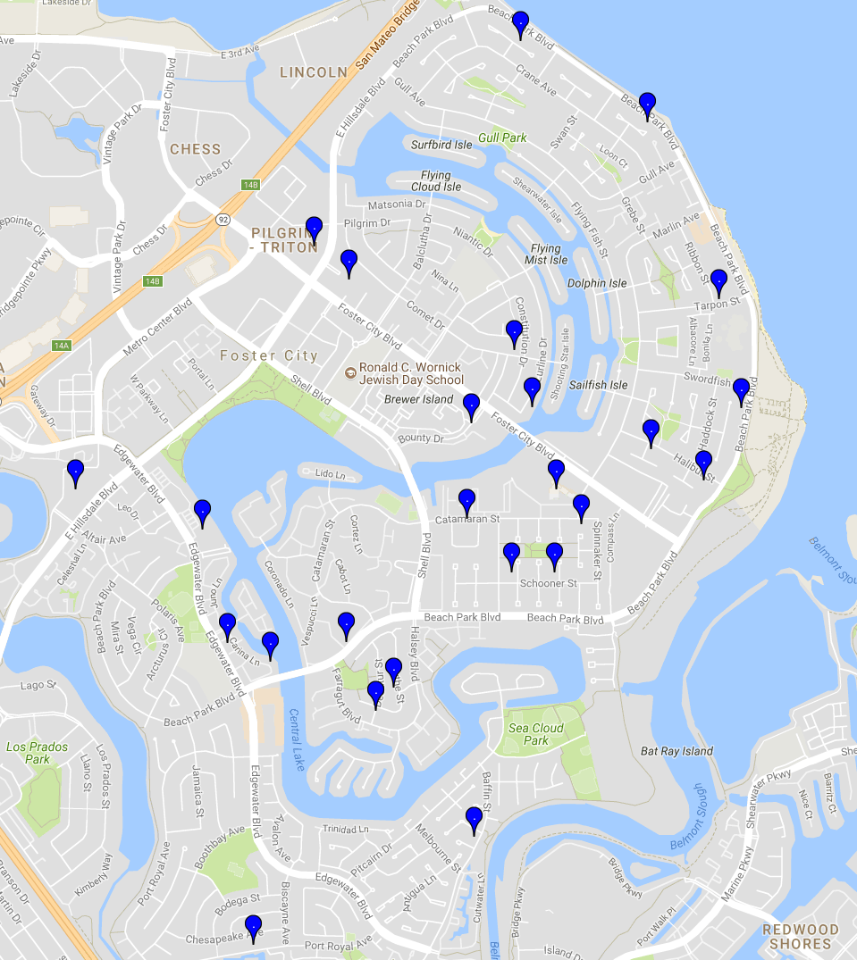

THEFTS FROM VEHICLES – INCLUDES AUTO BURGLARY
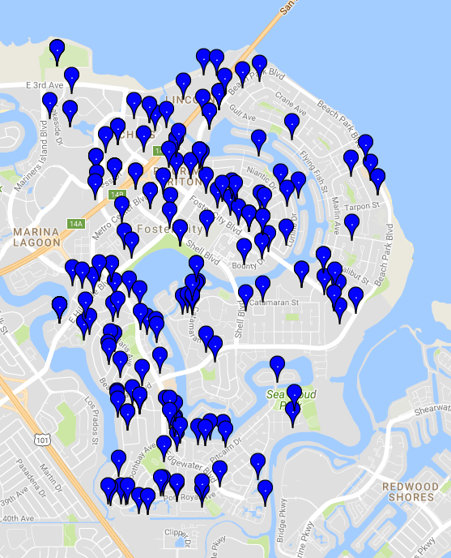

- There were 204 thefts from vehicles reports in 2017. Due to numerous thefts at the same locations, the pins on the map do not reflect all of the cases.

THEFTS
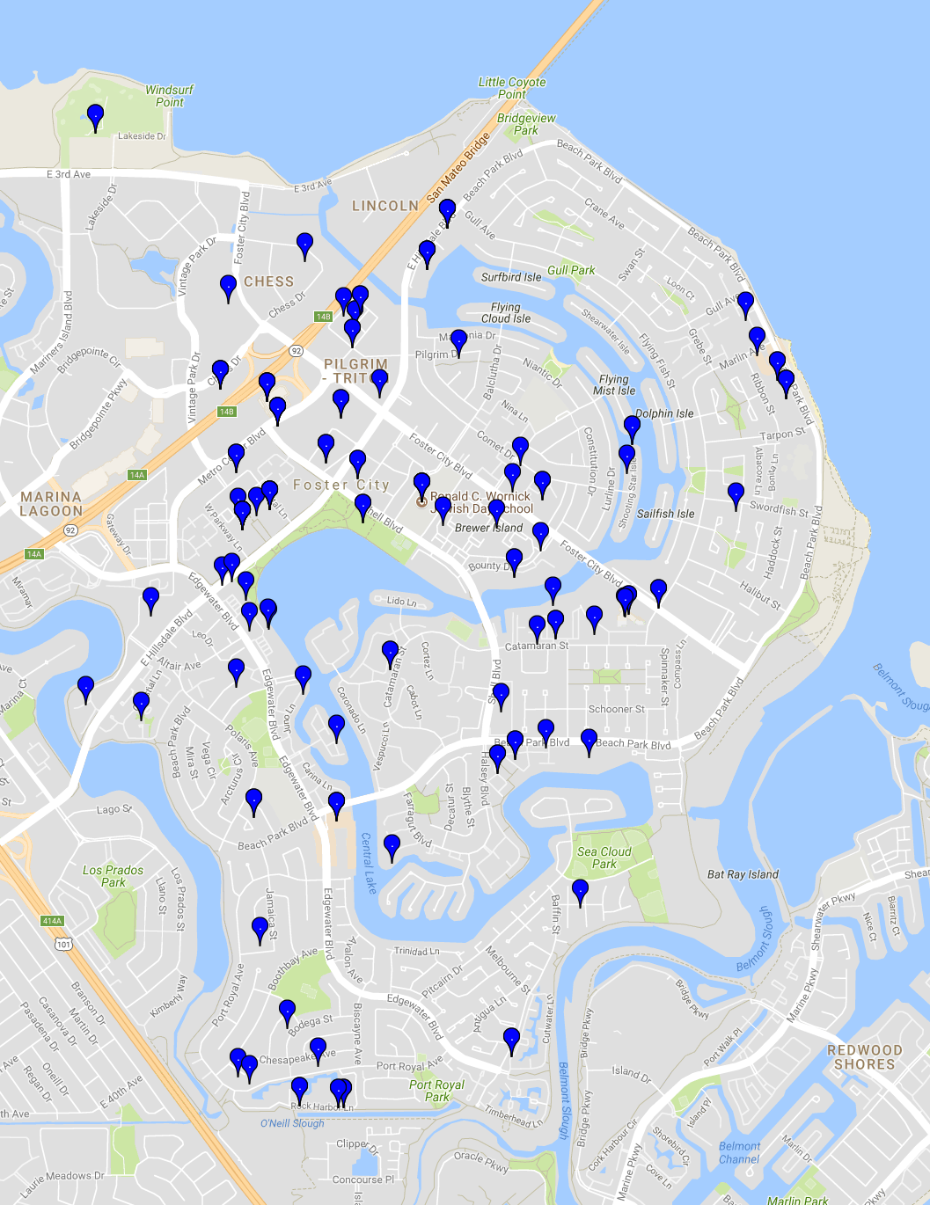

- There were 137 theft reports in 2017. Due to multiple thefts at the same locations, the pins on the map do not reflect all of the cases.
STOLEN VEHICLES
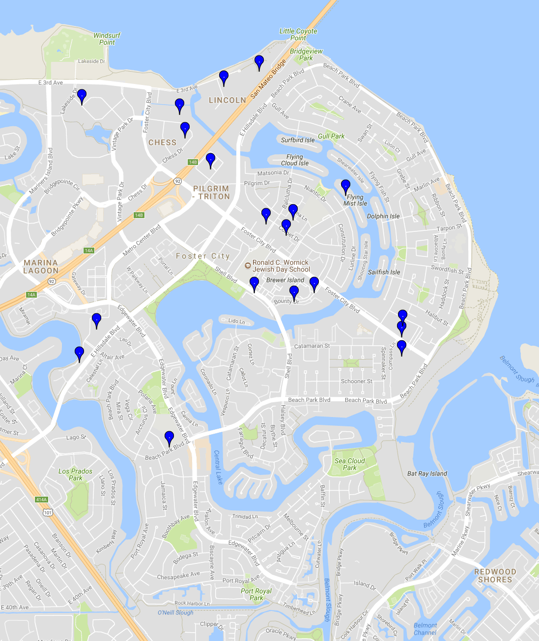

GRAFFITI
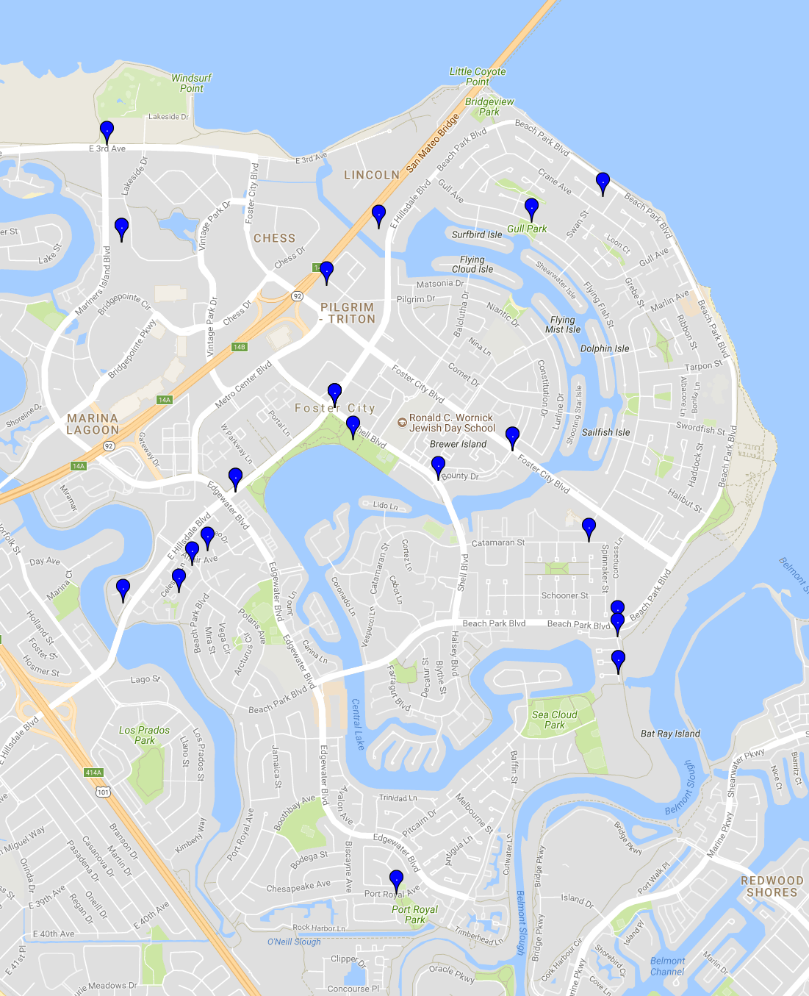

VANDALISM
