FOSTER CITY
POLICE DEPARTMENT

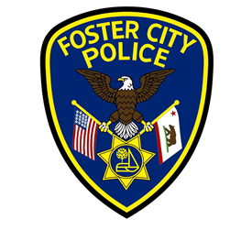

2017 ANNUAL TRAFFIC REPORT



Joseph Pierucci- Chief of Police

Report prepared by
Traffic Officer Michael Acosta

Table of Contents

Page 3 Introduction and Summary
Page 4 2017 Traffic Enforcement Events
Page 5 2017 Supported Community Events
Page 6 Moving Citations Statistics
Page 7 Collision Statistics
Page 9 Abandoned Vehicle Abatement
Page 10 Parking Violation Citation Statistics

Introduction

This document provides an overview of Foster City’s traffic statistics for the year of 2017. It also contains information about the Foster City Police Department’s involvement in community events, focused enforcement campaigns, regional traffic safety efforts, and efforts to mitigate local traffic congestion.
Summary

During 2017, traffic collisions in Foster City decreased noticeably from 2016. However, the number of reported injuries increased by 11 from 2016. Foster City did not have any fatalities as the result of vehicle collisions. Approximately 6% of the collisions involved a bicyclist or pedestrian. In the majority of collisions that involved a pedestrian or bicyclist, the involved vehicles traveled at low speeds. Additionally, these types of collisions occurred in parking lots, adjacent to driveways, or near a crosswalk. Consequently, the majority of injuries sustained in these types of collisions were classified as minor in nature.

During 2017, traffic and pedestrian safety remained the goal of enforcement and education efforts around the schools. Focused enforcement and education were conducted to mitigate traffic congestion during evening commute times resulting from heavy traffic on local highways. The Foster City Police Department supported several community events to enhance the safety of participants and attendees. Events such as the Fourth of July celebration and community bike ride were supported by officers providing pedestrian and vehicle traffic control, resulting in the events occurring without incident. Most importantly, participants and attendees experienced a safe and enjoyable event.

During 2017, the Foster City Police Department participated in local and regional traffic safety campaigns. The purpose of the campaigns was to enhance traffic safety by focusing enforcement on distracted drivers, DUI violators, and non-compliance with seat belt laws. Additionally, the Foster City Police Department participated in a county wide, multijurisdictional traffic safety program. The Foster City Police Department is committed to traffic safety in our community, and regionally, so it devotes significant resources to continue to meet that goal.

The 2017 traffic report includes the following noteworthy statistics:

- Overall, there were 195 collisions in 2017, a decrease of 25 from the 2016 total of 220.
- There were 51 people injured in vehicle collisions, an increase of 11 from 2016.
- There were 5 collisions that resulted from a driver being under the influence of alcohol/drugs—2.5% of all collisions.
- There were 7 collisions involving bicyclists—3.6% of all collisions.
- There were 5 collisions involving pedestrians—2.5% of all collisions.
- There were no fatal collisions in 2017.
- FCPD officers conducted 8,751 traffic enforcement stops, an increase of 2,035 stops over the 2016 total.
- FCPD officers issued citations (1,880) in approximately 21% of the stops and provided warnings in approximately 79% of stops.
- FCPD issued 1060 parking citations, an increase from the 2016 total of 874.

2017 Traffic Enforcement Events

Avoid the 23 Campaign

Throughout 2017, the Foster City Police Department participated in campaigns sponsored by the California Office of Traffic Safety aimed at mitigating driving under the influence of alcohol violations. Officers made 48 arrests for driving under the influence of alcohol and or drug violations, an average of 4 DUI arrests per month.

Operation Click it or Ticket

During the month of May, the Foster City Police Department joined more than 12,000 other law enforcement agencies in a nationwide effort to enforce seatbelt laws and increase compliance. This campaign is known as “Operation Click It or Ticket.”

During Operation Click It or Ticket, the Foster City Police Department issued 29 citations for the violation of not wearing a seatbelt and children being unrestrained. The public was educated on the importance of wearing seat belts and using child restraint systems. The majority of vehicle drivers and passengers have statistically been shown to wear seatbelts, so this event serves as an annual reminder for those already in compliance to continue the use of their seatbelts.

According to the California Office of Traffic Safety (OTS), the Click It or Ticket campaign debuted in California in 2005. Since then, the state’s seat belt use rate increased from 92.5 percent in 2005 to 97.1 percent in 2014 according to the National Highway Traffic Safety Administration (NHTSA) Seat Belt Usage Report. California’s compliance rate of 97.1 percent is higher than the national average of 87 percent. Seat belts help to save thousands of lives across America each year. Statistics indicate that motorists are 75% less likely to be killed in a rollover crash if they use a seatbelt.
Distracted Driving Campaign

In January of 2017, new legislation was enacted, which expanded the current laws on cellphone usage to include drivers who hold their phones in their hand while driving, regardless of whether they are actively using it. April was National Distracted Driver Awareness Month, which is a nationwide initiative aimed at decreasing cell phone related distracted driving. During this safety awareness campaign, the Foster City Police Department focused on identifying drivers who violated the cell phone usage laws. This enforcement effort resulted in the issuance of 104 citations for cell phone usage violations.

Driver distraction is a significant and growing problem nationwide. According to the NHTSA data for the year 2014, distraction-affected crashes killed 3,179 people nationwide (10% of all fatalities).

San Mateo County Saturation Traffic Enforcement Program (S.T.E.P.)

Each month in 2017, officers of the Foster City Police Department participated in the San Mateo County Saturation Traffic Enforcement Program, also known as the S.T.E.P. program. The objective of this program was to increase traffic safety awareness in order to reduce traffic related incidents and collisions resulting in injuries throughout San Mateo County. Each month, approximately 20 or more officers conducted concentrated traffic enforcement in two San Mateo County cities for the day. They would work in one city for four hours in the morning and then move to a second city for an additional four hours in the afternoon. Participating officers focused their traffic enforcement efforts to address specific traffic safety issues at locations identified by collision data, community complaints, or officer’s expert analysis. During the month of February 2017, S.T.E.P. focused their efforts within Foster City to enhance traffic safety. Participation in S.T.E.P. will continue in 2018.

Directed Enforcement within Foster City

During 2017, Foster City Police Officers regularly monitored major streets, intersections, streets around schools, and other high-traffic areas throughout Foster City. A priority for the Foster City Police Department was traffic safety around the schools during pick-up and drop-off times. Officers conducted focused enforcement patrols around the schools during times of high vehicle traffic. The Foster City Police Department also conducted focused traffic enforcement to mitigate congestion during the evening commute in the areas of the on-ramps to Highway 92, from Metro Center Boulevard and Chess Drive. The objective of the Department’s day-to-day proactive patrol activity was to enhance traffic safety by educating and enforcing common violations of traffic laws that cause vehicle collisions. This year, the traffic division partnered with Gilead Sciences to create a shuttle program for Gilead employees. Starting in the early part of the year, Bauer’s transportation began shuttling Gilead employees to work from various parts of the Bay Area, which made an impact in the overall number of vehicles on the road during the commute hours in Foster City.

2017 Supported Community Events

4th of July / Opening Day of Soccer / Head of the Lagoon

On July 4th, Foster City hosted a fireworks show in celebration of Independence Day. The event brought thousands of vehicles and pedestrians into our city. The Foster City Police Department utilized police officers, reserve police officers, community service officers, and officers from outside agencies to maintain a safe flow of traffic in and out of the city. The Emergency Operations Center was utilized as a command post for all operations during this event.

On September 9th, officers from the Foster City Police Department assisted the American Youth Soccer Organization for the opening day of the soccer season. Three officers, a community service officer, and a reserve officer assisted at the event by conducting pedestrian and vehicular traffic control to enhance safety.

In November, the Head of the Lagoon rowing event was held in Foster City. The event brought vehicle traffic and people into the city to participate and to view the event. The Foster City Police Department utilized reserve officers to assist with maintaining a safe flow of traffic in, out and around the event.

The Foster City Police Department wholeheartedly supported these community events and other smaller events. The Foster City Police Department is fully committed to enhancing safety at community events to keep Foster City a great place to live, work, and play.

Moving Citations

In 2017, officers conducted 8,751 traffic enforcement related stops. Officers issued a total of 2,995 traffic law violation/traffic related criminal citations. Citations were issued for 21% of the traffic enforcement stops, while warnings were given for the remaining 79% of the traffic enforcement stops. The graph below depicts the most common violations cited.

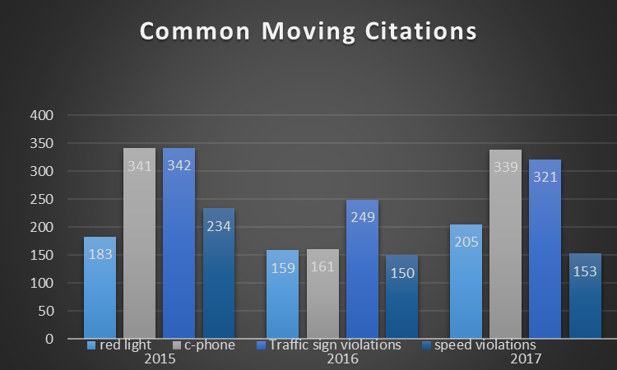

Collision Statistics

In 2017, there were 195 reported traffic collisions, a decrease of 25 collisions from the 2016 total. 132 collisions occurred on public roadways and 63 collisions occurred on private property. During 2017, a total of 51 people reported being injured (includes complaints of pain) as a result of vehicle collisions. This was an increase of 11 people from the 2016 total. Of the 51 people who reported they were injured, none sustained injuries classified as major injuries. No collision related fatalities occurred in 2017. The main Primary Collision Factor (PCF) for 2017 was unsafe turning movements, which were responsible for 42 of our 195 collisions. Unsafe backing was the PCF for 33 collisions, unsafe speed was the PCF for 32 collisions, and red light violations were the PCF for 14 collisions. In total, 121 out of 195 collisions were primarily caused due to these four violations.

2016 – 2017 COMPARISON CHART

*Refer to legend below
MOTOR VEHICLE COLLISIONS
LAST YEAR (2016) |  |  |  |  |  |  | THIS YEAR (2017)
 | SWITRS REPORTABLE | PRVT  PROP | PERSONS INJURED | FATAL | TOTAL |  | SWITRS REPORTABLE | PRVT  PROP | PERSONS INJURED | FATAL | TOTAL
JAN | 12 | 2 | 2 | 0 | 14 |  | 14 | 12 | 5 | 0 | 26
FEB | 14 | 8 | 4 | 0 | 22 |  | 14 | 4 | 5 | 0 | 18
MAR | 15 | 4 | 5 | 0 | 19 |  | 13 | 8 | 5 | 0 | 21
APR | 6 | 7 | 1 | 0 | 13 |  | 5 | 6 | 2 | 0 | 11
MAY | 14 | 8 | 6 | 0 | 22 |  | 14 | 5 | 7 | 0 | 19
JUNE | 11 | 2 | 2 | 0 | 13 |  | 13 | 7 | 6 | 0 | 20
JULY | 11 | 7 | 3 | 0 | 18 |  | 10 | 7 | 3 | 0 | 17
AUG | 14 | 6 | 3 | 0 | 20 |  | 11 | 2 | 5 | 0 | 13
SEPT | 15 | 4 | 5 | 0 | 19 |  | 11 | 3 | 9 | 0 | 14
OCT | 16 | 4 | 4 | 0 | 20 |  | 8 | 0 | 2 | 0 | 8
NOV | 15 | 6 | 5 | 0 | 21 |  | 9 | 5 | 0 | 0 | 14
DEC | 6 | 13 | 0 | 0 | 19 |  | 10 | 4 | 2 | 0 | 14
TOTAL | 149 | 70 | 40 | 0 | 220 |  | 132 | 63 | 51 | 0 | 195

*Comparison Chart Legend:

SWITRS/REPORT TO STATE: All reported collisions that occurred on a public roadway.

PRVT PROP: All reported collisions that occurred on private property.

PERSONS INJURED: The number of injured persons in collisions that occurred on either a public roadway or on private property.

FATAL: The number fatalities that occurred a result of a collision.

Collisions over five years:

Collisions decreased by 25 in 2017 from 2016, which put us below 200 collisions for the first time in over six (6) years. The Foster City Police Department continued to conduct proactive traffic enforcement to enhance traffic safety and it will continue to be one of our primary goals
for 2018. With the increase in staffing levels during 2017, the presence of police vehicles on the streets cannot be dismissed as being a major contributing factor to the decrease in collisions.

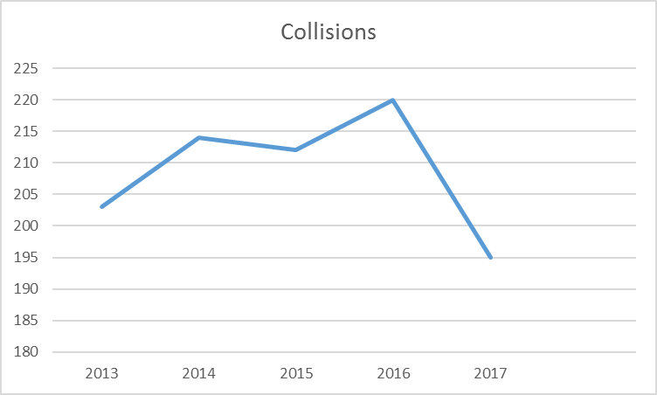

Collisions Involving Bicyclists

During 2017, there were seven collisions involving a vehicle and a bicyclist. No bicyclists sustained injuries categorized as major injuries. All bicyclists sustained minor injuries or complained of pain that resulted from low speed, low impact collisions. The majority occurred as a vehicle exited a driveway at slow speed or the vehicle proceeded ahead after slowing or stopping before driving through a crosswalk. The rate of occurrence for vehicle collisions involving a bicyclist was less than one per month.

Collisions Involving Pedestrians

There were five collisions involving a vehicle and a pedestrian and no major injuries occurred. All of the collisions occurred in either a private parking lot, or as a vehicle was exiting from private property onto a public roadway. The rate of occurrence for vehicle collisions involving pedestrians was less than one per month.

Driving Under the Influence of Alcohol Collisions

During 2017, there were five collisions related to violations of driving under the influence (DUI) of alcohol/drugs. Of the five collisions, only one reported minor injuries as the result of the collision. There were no fatalities resulting from collisions related to violations of driving under the influence (DUI) of alcohol/drugs.

Collisions with Fatalities

During 2017, Foster City had zero fatal vehicle collisions. Over the last 21 years, two fatal vehicle collisions occurred, both in 2013.

Abandoned Vehicle Abatement

The Foster City Police Department monitors vehicles that are parked for periods more than 72 hours in accordance with Foster City municipal code. If a vehicle is not moved after 72 hours, the vehicle is issued a citation and a notice to move. If the vehicle remains parked for an additional 72 hours, the vehicle is then towed under California State law.

During 2017, 490 vehicles were monitored for the 72 hour observation and 118 citations were issued to vehicles for being parked for over 72 hours. This was a decrease of 12 citations from the previous year. FCPD towed 17 vehicles for being parked in violation of the 72 hour municipal code, which was an increase of 10 tows from the previous year.

Abandoned Vehicles Statistics Chart

Top of Form
72-Hour Observation / 11-24 Statistics
Bottom of Form

Month | Vehicles | Observations  Made | Citations | Towed | % Cited | % Towed  After Cite
January | 27 | 61 | 8 | 0 | 29.63% | 0
February | 30 | 83 | 14 | 1 | 46.67% | 7.14%
March | 35 | 117 | 12 | 3 | 34.29% | 25%
April | 41 | 93 | 11 | 3 | 26.83% | 27.27%
May | 64 | 177 | 19 | 5 | 29.69% | 26.32%
June | 59 | 105 | 11 | 0 | 18.64% | 0
July | 86 | 221 | 18 | 1 | 20.93% | 5.56%
August | 61 | 151 | 12 | 3 | 19.67% | 25%
September | 40 | 99 | 9 | 0 | 22.5% | 0
October | 20 | 40 | 3 | 0 | 15% | 0
November | 16 | 60 | 1 | 1 | 6.25% | 100%
December | 11 | 13 | 0 | 0 | 0 | 0
2017 Total | 490 | 1220 | 118 | 17 | 24.08% | 14.14%
2016 Total | 435 | 1394 | 130 | 7 | 29.89% | 5.38%
Difference | +55 | -174 | -12 | +10 | -5.81% | +8.76%

Parking Violation Statistics

In 2017, 1060 parking citations were issued, which was an increase of 186 citations issued as compared to 2016. The graph below depicts the most common parking violations cited.

