# Remote Desktop Connection (Terminal) Login Instructions.

1. Go to [https://terminal.fostercity.org](https://terminal.fostercity.org/) using a web browser.

2. Sign in with your Foster City username and password:

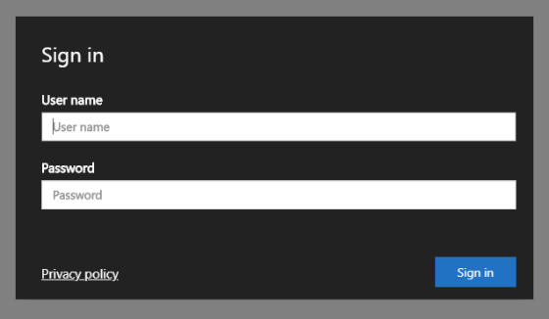

3. Click on Terminal Users under Work Resources:

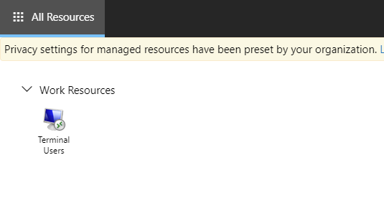

4. Click Allow:

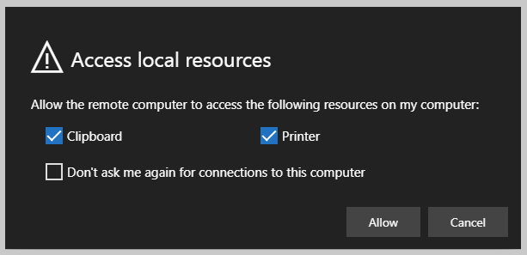

5. You are now logged on to Remote Terminal. Click on the diagonal arrows to go full screen:

