# Signing in to check email (Office 365)

Go to **Outlook.com**

Click **Log In**

Enter your work email address:

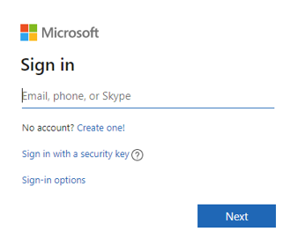

Select Work/School account:

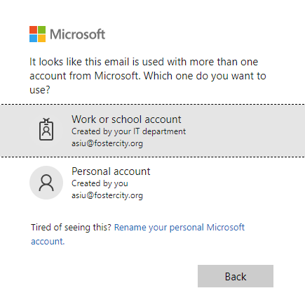

Enter your email password